Town of Enfield
Regular Town Board Meeting
Wednesday, June 8, 2022, 6:30 p.m.
Virtual Meeting via Zoom Meeting

Present: Town Supervisor Stephanie Redmond; Town Councilpersons; Robert Lynch, Cassandra Hinkle, James Ricks, Jude Lemke; Town Clerk Mary Cornell

Call to order: Supervisor Redmond called the meeting to order at 6:30 pm

Privilege of the Floor: Art Godin spoke on behalf of the Enfield Anti-Racist group - he gave an update on the Cayuga Nation and their requests to several government agencies to remove Clint Halftown as leader of the Cayuga Nation. Ed & Helen Hetherington led the assemblage in the Pledge of Allegiance. Robert Lynch informed the board on how he spent his Memorial Day – Legislators in Albany had planned to pass at the end of their legislation season to change local elections to be moved to even years instead of odd years. He sent emails to government officials and with the efforts of many others throughout the state, the State Legislature will not pursue this legislation this season.

Additions & Changes to the Agenda: Supervisor Redmond shared the following additions; Town Clerk and Town Bookkeeper items to purchase, return to in person meetings, additional expense for the Salt Barn.

Quarterly Reports:

Water Protection Committee: Nancy Spero. Steve Winkly is continuing to work with the Water Protection Committee, Dan Walker has attended some of the meetings and has taken information back to the Town Planning Board. Soil & Water has been mapping well water usage in the Town which will help with planning in the future. They had two visitors from the Fingerlakes Land Trust, Sachem Sam George introduced himself and was able to see what the committee is working on. They discussed Flood Insurance and that Enfield is the only Town in the County not involved. Their next meeting will be held on July 27th at 7 pm.

Enfield Community Council: Robert Lynch. Since his last report to this town on March 9th, they have held three meetings. The Community Council held the Rhubarb Festival (replacing the Country Faire) $1,334.50 proceeds. The ECC is hopeful to rebuild the Enfield Summer Camp, they currently have ~27 enrolled. Their current focus is the needs assessment survey (Meghan Lyons, Tompkins County Youth Services). The Survey results will assist with next year’s Budget planning. The Annual Harvest festival will be held on September 24.

Enfield Food Pantry: Diane Aramini. The Food Bank of the Southern Tier is working with the Enfield Food Pantry to secure funding for the pantries needs. The full report is on file with the Town Clerk.

Cayuga Lake Watershed IO: Stephanie Redmond. They are working on updating their website. They are looking at the realignment of Salmon Creek. They are working on getting projects started in Seneca & County. The Sheldrake Creek has flooded and they are looking at ways to. Municipalities are being asked for cost estimates for water and sewer improvements/Maintenance. They have been working with the Water Resource Council to divvy up projects. They are working on a white paper that will explain the implications of Salt usage on roads.

Tompkins County Health Consortium: Stephanie Redmond. They are concerned they are losing members and what this will do to the stabilization of the program. They are working on educational materials to let individuals know the many benefits of staying with them. They are working onlong-term planning for employees and they have a Face Book Page.

Cemetery Committee: Cassandra Hinkle. She spoke with Matt Lincoln about removing the debris from the cemetery clean-up. Robert Lynch thanked Cassandra and her family for picking up his mess at the Rolfe Cemetery. He has taken on the task of cleaning and cutting away debris from the perimeters. The Cemeteries are looking better and we need to find funds to replace headstones and graves that are being lost. He noted he saw Gopher holes.

Environmental Management Council: Stephanie Redmond. Six Mile Creek has amphibian road crossing signs, as they are on the move with breeding/laying eggs. They had a presentation on Crop Soil resiliency and planning. They organized many events for Earth Day.

Monthly Reports:

County Legislator: Anne Koreman. They have a firm hired to disburse the ARPA fund and have a small committee of legislatures to help the firm approve/select grants. Randy Brown and she met with the Grange to discuss their needs. The legislatures did pass a virtual meetings law to continue virtual meetings that are allowed by NYS. A quorum has to be in person and others with extenuating circumstances can attend virtually. They will still have Hybrid meetings. The County legislative independent redistricting will be presented with their recommendions for redistricting areas. Enfield will still be split in two districts. They celebrated a proclamation for LGBTQ Pride month and Juneteenth (It is a County Holiday for employees).

Town Supervisor’s Report: Stephanie Redmond. She attended meetings with other town supervisors, attended meetings hosted by the county. She gave the new Town Intern a tour of the Town and informed her of the projects that we are working on. She spent many hours last month working on several grants that needed to be submitted by early June, they have been submitted. She has been meeting regularly with the ARPA Committee, she met with the Water protection committee, and attended the Town Planning Board Meeting. She spoke with the IDA about the lack of impact the town has. Councilperson Lynch thanked Supervisor Redmond for going to the IDA and representing the Town.

Town Clerk Report: Mary Cornell – The Clerks office issued new and renewal dog licenses. Collected funds for building permits as well as performing the normal duties of the office.

Code Enforcement Report: Alan Teeter. Last Month he issued 8 permits, which brings the year-to-date total to 23. He issued 5 new addresses. A 4-unit apartment building was previously approved on Mecklenburg Rd, the contractor has renewed his building permit. He has worked on the Code law and will send it on to the Town Board when completed. He issued a permit for a firework permit on Harvey Hill Rd (We do not currently charge a fee, the town board should look at setting a fee for the permit. Alan will draft a resolution to charge $50 for the Fireworks permit.

Volunteer Fire Company: Alan Teeter. Last month a total of 17 calls; the trainings for this month will include E&V propane truck training, CPR training (2-part, will take place over two nights). They will do a ladder truck training with Lansing at some point this summer.

Tompkins County Council of Govts: Robert Lynch – No Report this month

Consent Agenda:

Audit Claims - General Fund Vouchers #124 to 143 dated June 8, 2022 in the amount of $15,699.93. Highway Fund Vouchers # 95-109 dated June 8, 2022 in the amount of $11,538.89
Approval of April and May Minutes

Supervisor Redmond moved and Councilperson Lynch seconded.

VOTE: Councilperson Hinkle, Aye; Councilperson Lemke, Abstain; Councilperson Lynch, Aye, Councilperson Ricks, Abstain; Supervisor Redmond, Aye; Carried.

New Business:

Resolution #60-2022 Authorization to Sign the New York State Municipal Workers’ Compensation Alliance Agreement

WHEREAS the Town of Enfield is required by New York State law to provide workers compensation and employers liability coverage, therefore be it;

RESOLVED, the Town Board authorizes Supervisor Redmond to renew the New York State Municipal Workers’ Compensation Alliance Agreement for 2023.

Supervisor Redmond moved and Councilperson Hinkle seconded. No Discussion.

Vote: Councilperson Hinke, Aye; Councilperson Lemke, Aye; Councilperson Lynch, Aye; Councilperson Ricks, Aye; Supervisor Redmond, Aye; Carried.

EV Charging Station: Joe Desimone from Greenspot. They install, maintain, and operate EV charging stations. A small percentage of the profit is returned to the municipality. The utilize any incentives that utility companies offer. Supervisor Redmond asked what would be the need from the town (space and energy needs), she is also worried about the need for the stations in the community. Joe explained as the infrastructure is installed people will use them. He shared that no community is too small. They look for public property that the municipality owns, they would be given rights to install and operate in the community – They can also set up on any commercial property. It is up to the municipality to determine where they would like the equipment to go. If the Town would like them to move forward then they could come out to look at the areas and determine the needs. Councilperson Lemke asked about pricing and limitations of other vendors in the area. The rates are set on the cost of electricity in the area, and to set the pricing they have to price it competitively so that people want to use it. It is a third of the cost of gasoline at this time. If they select a property then other vendors cannot also use the area. The way revenue sharing with the town works – They collect the revenue and deduct all expenses and they set a fixed spread (Which is what they can share with the municipality) they share 25% of the 10 cents. It is not a lot of revenue to be redeemed. Councilperson Lynch asked if they are slow-speed chargers or fast-speed chargers. The Slow charges give 20-30 miles per hour. The fast chargers are three times faster and reduce the amount of time you would need to leave the vehicle. Councilperson Lynch confirmed that there are no outright expenses to the town only the utilization of town property.

Discussion: Community Rating System and the National Flood Insurance Program; Supervisor Redmond shared that we would need to adopt a flood plain management ordinance. If we do not enforce the requirements, we would get a one- year suspension and/or suspension from the program if we continue to not enforce the requirements. If we do not participate and there is a flood then we would not qualify for Federal FEMA recovery funds. Lansing was a case study for the CRS (Community Rating System) and they found it not to be a significant savings or a sufficient use of town personnel’s time. Councilperson Lemke is flood insurance available in the Town currently. Supervisor Redmond shared that Insurance Companies will not provide flood insurance if we are not signed up for the NFIP (National Flood Insurance Program). Supervisor Redmond had sent out videos and information via email to the Town Board members and she would like to hear other board members thoughts on this. Councilperson Lemke asked if we had a sense of how many residents are impacted by this. Councilperson Hinkle asked how long we have to decide? Supervisor Redmond suggested contacting someone to attend a Town Board meeting to provide more information. She will reach out to Tompkins County Soil & Water or similar experts to see if they would be willing to come to a meeting to explain/discuss this further with the Town Board before the Board makes a decision.

Discussion: Zoning. Supervisor Redmond made a motion to ask the Town Planning Board to explain what Zoning would look like in the Town of Enfield and Councilperson Ricks seconded. Zoning can be one of the only ways that a Town Board can regulate what comes into our town. Councilperson Lemke, she has heard concerns on how many solar farms the town is willing to consider allowing in the town. Zoning is really the only tool that can be used to control solar farms, etc. It is a controversial topic that we should look at further. Diane Aramini – Zoning can help in our town which could require land owners to keep their properties clean and not allow a lot of junk collection on properties. Councilperson Lemke shared the Town does have a junk car law from ~1994. Councilperson Hinkle shared that having further discussions could be helpful. Councilperson Lynch shared three things can’t be said in this town, Fracking, Solar Farms, and Zoning. He has only heard one constituent state that we need zoning, so he is going to stand back on this matter as it is controversial and he does not want to be involved in another issue the divides our community. Councilperson Lemke would like to find out more of what Zoning is and maybe we should reach out to Guy Krough for a better understanding before moving forward, she will reach out to Dan and ask if he can explain how zoning works in general if he is the correct person to do so.
This discussion has been tabled and will be brought back to the Town Board at a future Town Board meeting.

Vote: Councilperson Hinke, Aye; Councilperson Lemke, Aye; Councilperson Lynch, Aye; Councilperson Ricks, Aye, Supervisor Redmond, Aye; Carried.

Tax Cap Override – Supervisor Redmond motioned to set a Public Hearing for July 13, at 6:00 pm, and Councilperson Lemke seconded. Discussion:

Vote: Councilperson Hinke, Aye; Councilperson Lemke, Aye; Councilperson Lynch, Aye; Councilperson Ricks, Aye, Supervisor Redmond, Aye; Carried.

Councilperson Lynch suggested moving the time to 6:30 as we may not have a lot in attendance. The time has been amended to 6:30 pm.

Vote: Councilperson Hinke, Aye; Councilperson Lemke, Aye; Councilperson Lynch, Aye; Councilperson Ricks, Aye, Supervisor Redmond, Aye; Carried. Comment by Councilperson Lynch there might be some controversy this year as inflation has caused concerns among many people.

Clerk and Bookkeeper needs - Supervisor Redmond shared the need for laptops for both the Town Clerk and for the Town Bookkeeper. Supervisor Redmond motioned that we use ARPA funds and Councilperson Lemke seconded.

Vote: Councilperson Hinke, Aye; Councilperson Lemke, Aye; Councilperson Lynch, Aye; Councilperson Ricks, Aye, Supervisor Redmond, Aye; Carried.

Copier need - Councilperson Hinkle motioned to authorize the clerk to use funds up to $5,000 for a commercial copier purchase and Supervisor Redmond seconded.

Vote: Councilperson Hinke, Aye; Councilperson Lemke, Aye; Councilperson Lynch, Aye; Councilperson Ricks, Aye, Supervisor Redmond, Aye; Carried.

A Resolution Authorizing a Public Hearing on Local Law No. _____ of 2022 – Allowing the Town Board to Continue to Hold Virtual Public Meetings

RESOLUTION #2022-Tabled

Whereas, on April 9, 2022, Governor Hochul signed an amendment to the Open Meetings Law to allow (until July 1, 2024) expanded use of videoconferencing by public bodies in the conduct of open meetings, under extraordinary circumstances, regardless of a declaration of emergency; and

Whereas, passage of a Local Law is necessary for the Town of Enfield to implement this amendment’s provisions; now therefore be it

Resolved, that a Public Hearing will be held before the Enfield Town Board on July 13, 2022, beginning at 6:30 PM in the Enfield Courthouse, 182 Enfield Main Road, Enfield, NY, and/or (exclusively, if permitted by law or executive order) virtually via zoom, for the purpose of considering Local Law No. _____ of 2022, a Local Law Allowing the Town Board to Continue to Hold Virtual Public Meetings; and be it further

Resolved, that the Town Clerk is authorized and directed to place proper notice of such Public Hearing in the official newspaper of the Town.

Councilperson Lynch explained that Governor Hochul released a law where municipalities should come back into their meeting locations to conduct meetings. With new legislation that allows some latitude to allow some legislatures to appear remotely (extenuating circumstances). A quorum needs to be in person at a fixed location, remote attendees can vote as long as a quorum is in person.
Councilperson Lynched moved the following Resolution and Councilperson Lemke seconded for discussion purposes.
Discussion: Councilperson Lemke in order to adopt the law there are some decisions that the Town would need to make before creating a local law. We need to talk about this more before setting the law. She would like to go through the law more as the law is poorly written and she would like to examine it further and reach out to the AOT for further guidance and we may need to hold a special meeting to set a public hearing.

Supervisor Redmond moved to table and Councilperson Lynch seconded to table until the July meeting unless we receive information earlier.

Vote: Councilperson Hinke, Aye; Councilperson Lemke, Aye; Councilperson Lynch, Aye; Councilperson Ricks, Aye, Supervisor Redmond, Aye; Carried.

RESOLUTION NO. 61-2022 – Approval of June 2022 Budget Modifications

WHEREAS, it is necessary to modify the 2022 budget based on updated estimates of revenues and expenditures in 2022,

and WHEREAS, a detailed listing and description of each budget adjustment by Fund has been provided to the Town Board for review as presented below, be it therefore
RESOLVED, that the Enfield Town Board approves the budget modifications as outlined below.

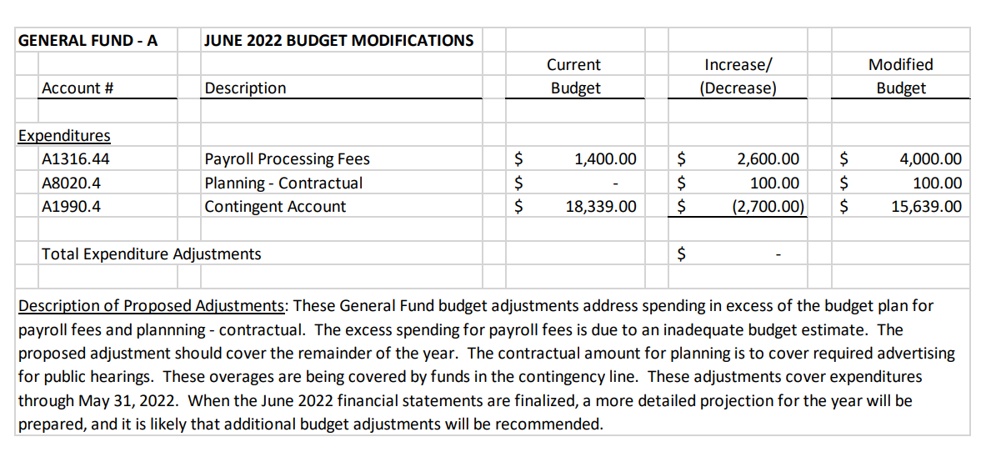
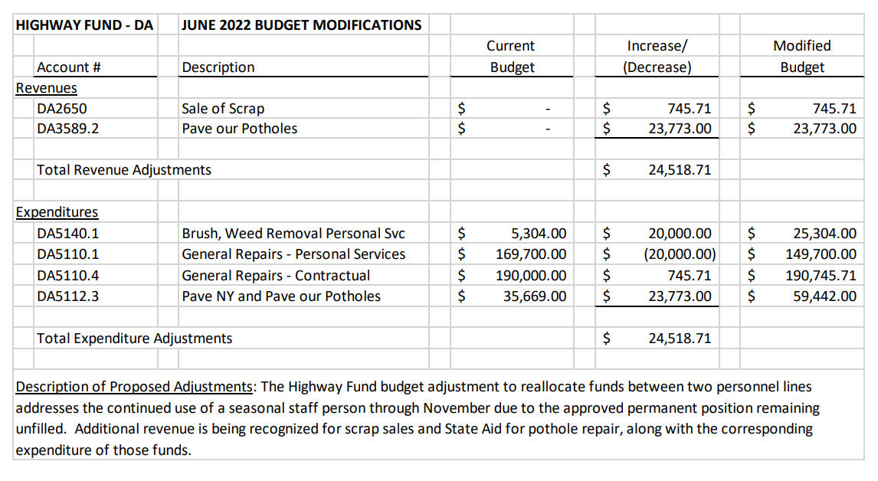
Supervisor Redmond moved and Councilperson Hinkle seconded. Discussion: Blixy will present at the July Board meeting to discuss where the current budget is will increased costs we have experienced this year.

Vote: Councilperson Hinke, Aye; Councilperson Lemke, Aye; Councilperson Lynch, Aye; Councilperson Ricks, Aye, Supervisor Redmond, Aye; Carried.

Wall for Salt Barn - Supervisor Redmond shared that she has received an updated construction cost from Parklane construction for a 6x6 below crib wall with a, additional cost of $7,025 and Highway Superintendent Rollins agrees that we should do this.

A Resolution to Rescind Resolution No. 63 of 2021 and Authorize Alternate Measures to Improve
Safety and Convenience at the Enfield Food Pantry
RESOLUTION # 62-2022

Whereas, by Resolution #63-2021, adopted at a Regular Meeting of the Enfield Town Board on May 12,
2021, this Board agreed “to have the area in front of the Community Building [since renamed the
‘Enfield Courthouse’]paved with poured concrete” and additionally authorized the Town Supervisor to
retain King Concrete to perform the paving work; and

Whereas, at the time of the authorization, the Town Highway Superintendent had expressed a
willingness to assist in certain site preparation efforts in connection with this project so as to reduce the
contractual costs to the Town; and

Whereas, the authorized contract with King Concrete was, for various reasons, never finally negotiated,
and the paving work at the Enfield Courthouse was never performed; and

Whereas, subsequent to this Town Board’s action of May 12, 2021, the Director of the Enfield Food
Pantry, whose organization would primarily benefit from this authorized improvement, has expressed
reservations about the project insofar as the Food Pantry might need to close or otherwise severely
curtail its food distribution operations for a protracted period during the dates of construction, thereby
placing Food Pantry patrons at heightened risk of food insecurity; and

Whereas, this Town Board has budgeted up to $25,000 for the repaving project, with King Concrete’s
quoted contract estimate stated at $12,750 on the date of the afore-stated authorization; and
Whereas, this Town Board desires to improve the safety of the parking area in front of the Enfield
Courthouse, as well as its convenience, for the benefit of pantry patrons and for the benefit of Food
Pantry volunteer staff, while also recognizing the concerns of the Food Pantry’s leadership and the need
to complete parking area improvements as quickly as possible and in a way that minimizes disruption to
Food Pantry operations; therefore be it

Resolved, that the Enfield Town Board hereby RESCINDS Resolution 63-2021, as no longer operating in
the best interests of the Town, and be it further

Resolved, that this Town Board authorizes and encourages the director of the Enfield Food Pantry, the
Town Supervisor, and the Town Highway Superintendent to confer about alternate, less disruptive
short-term improvements that can be made to level, harden, smooth, and otherwise enhance the
parking and pedestrian areas in front of the Enfield Courthouse, improvements that would not involve
long-term curtailment of Food Pantry operations; and be it further

Resolved, that this Town Board redirects the $12,750 that was initially authorized to cover King
Concrete’s services to, instead, underwrite the Highway Superintendent’s expenses for materials and
those other costs associated with the short-term improvements authorized by this Resolution, and
further, that if estimated costs should exceed the sum of $12,750, this Town Board will, as the need
arises, re-visit the project to consider additional necessary funding.

Councilperson Lynch moved the following resolution and Councilperson Lemke seconded. Discussion: Councilperson Lynch - A year ago the Town Board authorized the expense $12,750 to cover King Construction to pave the driveway. We had authorized $25,000 for the project. The paving was delayed due to a delay of scheduling and the paving was to start in the winter and on further consideration on the way it was being proposed that it was not the time to proceed. It would not allow use of the food pantry while the paving was taking place. We can’t allow for the pantry to be closed for multiple weeks. He spoke with Pantry director Jean Owens and she was in agreement that if the board was to choose something temporary that will work for all she is in agreement with it.

Vote: Councilperson Hinke, Aye; Councilperson Lemke, Aye; Councilperson Lynch, Aye; Councilperson Ricks, Aye, Supervisor Redmond, Aye; Carried.

Privilege of the Floor: Stephanie Redmond will be presenter on Discover Cayuga Lake on Salt runoff issues on June 29th. James Ricks mentioned the Peace Trot on Fathers Day.
Ed Hetherington asked about the street lights and the shrubs around the lights. Supervisor Redmond will speak with Superintendent Rollins to see if his employees can assist with the mowing/pruning.
Councilperson Lynch would like the highway superintendent to give check over the mower and weed eater to make sure they are in working order.
Marcus Gingerich – he is confused as to what Greenspot had explained on that impact on the Town lands if someone gets hurt and that there are a lot of things that could be problematic. Ed H. asked how many cars can be charged at each charger (Councilperson Lemke stated 1 car per station). Supervisor Redmond will email Greenspot to ask them the liability question.

Announcements: Rabies Clinic at the Highway Department tomorrow night at 7 pm.

Motion to adjourn: Councilperson Lemke motioned to adjourn and Councilperson Hinkle seconded; Adjourned 9:10 pm.

Respectfully submitted,

Mary Cornell

Mary Cornell
Town Clerk

